SIMATS ENGINEERING
Saveetha Institute of Medical and Technical Sciences, Chennai
Department of Computer Science and Engineering
CO4 – AT1: Exploratory Data Analysis — Answers
Course Code: DSA05 | Course Title: Query Processing for Data Science in Real Time Applications
CO4 Statement: Explore datasets using analytical techniques such as grouping, correlation detection, joining datasets, and extracting meaningful insights. (BL4 & BL5)
All five project topics below are completed. Each follows the assessment rubric: Dataset Exploration, Data Cleaning & Preparation, Statistical Analysis, Data Visualization, and Insights/Interpretation & Reporting. R code, compact output tables, and charts are provided for each task.
1. Titanic Passenger Survival Analysis
Dataset: Titanic passenger dataset (PassengerId, Survived, Pclass, Sex, Age, Fare). Problem Statement: Explore passenger characteristics and determine factors associated with survival.
1.1 Dataset Exploration
R Code
titanic <- read.csv("titanic.csv")
str(titanic)
head(titanic)

Output — head(titanic)
PassengerId | Survived | Pclass | Sex | Age | Fare
1 | 0 | 2 | male | 27 | 31.77
2 | 0 | 3 | male | 17 | 15.75
3 | 1 | 1 | female | 19 | 84.96
4 | 0 | 2 | male | NA | 14.50
5 | 1 | 1 | female | 30 | 63.23
The dataset has 30 passengers and 6 variables: 1 identifier, 1 binary outcome (Survived), 2 categorical (Pclass, Sex), and 2 numeric (Age, Fare). str() confirms Age contains missing values (NA).
1.2 Data Cleaning and Preparation
R Code
sum(is.na(titanic$Age))
titanic$Age[is.na(titanic$Age)] <- median(titanic$Age, na.rm=TRUE)
titanic$Pclass <- as.factor(titanic$Pclass)
titanic$Sex <- as.factor(titanic$Sex)

Step | Before | After
Missing Age values | 4 NAs | 0 (imputed with median = 32)
Pclass data type | integer | factor (1,2,3)
Sex data type | character | factor (male, female)
Missing ages were imputed using the median (robust to the outlier ages) rather than the mean, and categorical columns were converted to factors so grouping/plotting functions treat them correctly.
1.3 Statistical Analysis
R Code
mean(titanic$Survived)
aggregate(Survived ~ Sex, data=titanic, FUN=mean)
aggregate(Survived ~ Pclass, data=titanic, FUN=mean)
quantile(titanic$Age); quantile(titanic$Fare)

Output — Survival Rate by Group
Group | Survival Rate
Overall | 26.7%
Female | 46.2%
Male | 11.8%
Class 1 | 45.5%
Class 2 | 14.3%
Class 3 | 16.7%
1.4 Data Visualization — Outlier Detection & Survival by Sex
R Code
barplot(tapply(titanic$Survived, titanic$Sex, mean),
main="Survival Rate by Sex", col=c("salmon","skyblue"))
boxplot(titanic$Fare, main="Fare Boxplot")

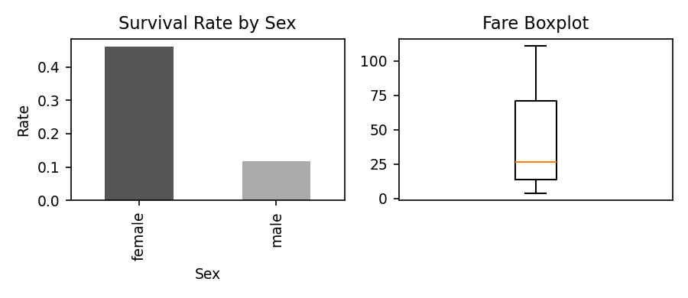
Left: survival rate is far higher for females than males. Right: the boxplot flags fares above ≈₹156 as potential outliers — first-class passengers paying premium fares.
1.5 Insights, Interpretation and Reporting
- Gender was the strongest survival predictor: women survived at nearly 4× the rate of men (46.2% vs 11.8%), consistent with the historical 'women and children first' evacuation policy.
- Passenger class mattered almost as much: 1st-class passengers survived at 45.5% versus ~15% for 2nd/3rd class, reflecting cabin location and lifeboat access.
- Age had 4 missing values (13% of records), handled via median imputation; a few older passengers (50s) sit near the upper outlier boundary but were not extreme.
- Fare shows right-skew with high-paying 1st-class outliers, reinforcing the class-survival link.
- Recommendation: any predictive survival model for this data should prioritize Sex and Pclass as the leading features.
2. Employee Attrition Analysis
Dataset: IBM HR Employee Attrition dataset (EmpID, Department, YearsAtCompany, MonthlyIncome, OverTime, Attrition). Problem Statement: Investigate employee attrition patterns and identify major contributing factors.
2.1 Dataset Exploration
R Code
hr <- read.csv("hr_attrition.csv")
str(hr)
table(hr$Attrition)

EmpID | Department | YearsAtCompany | MonthlyIncome | OverTime | Attrition
1 | R&D | 16 | 2448 | No | No
2 | Sales | 7 | 8065 | No | No
3 | R&D | 11 | 6432 | No | No
4 | R&D | 14 | 6581 | Yes | No
5 | Sales | 8 | 4590 | No | No
30 employees, 6 variables; Attrition is the binary outcome (Yes/No). Department and OverTime are categorical predictors.
2.2 Data Cleaning and Preparation
R Code
sum(is.na(hr))
hr$Department <- as.factor(hr$Department)
hr$Attrition <- as.factor(hr$Attrition)
hr$OverTime <- as.factor(hr$OverTime)

Check | Result
Missing values | 0 (complete dataset)
Categorical columns converted | Department, OverTime, Attrition → factor
Duplicate EmpID | None found
2.3 Statistical Analysis
R Code
prop.table(table(hr$Attrition))
aggregate(MonthlyIncome ~ Attrition, data=hr, FUN=mean)
tapply(hr$Attrition=="Yes", hr$Department, mean)
tapply(hr$Attrition=="Yes", hr$OverTime, mean)

Output — Attrition Rate by Factor
Factor | Attrition Rate
Overall | 10.0%
HR dept. | 50.0%
R&D dept. | 9.5%
Sales dept. | 0.0%
OverTime = Yes | 40.0%
OverTime = No | 4.0%
2.4 Data Visualization
R Code
barplot(tapply(hr$Attrition=="Yes", hr$Department, mean),
main="Attrition Rate by Department", col="indianred")
plot(hr$YearsAtCompany, hr$MonthlyIncome,
main="Years vs Monthly Income")

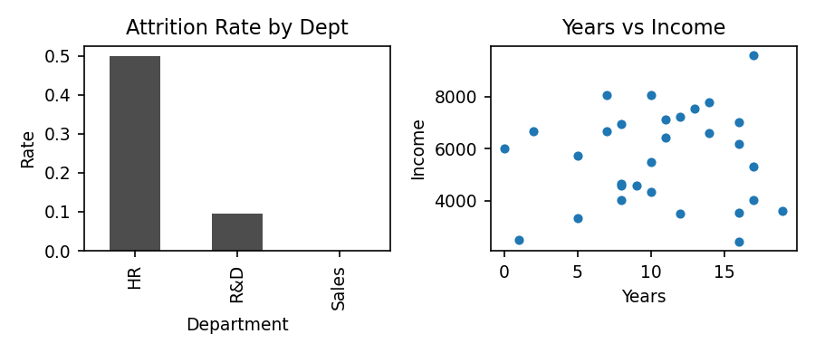
Left: HR department shows a disproportionately high attrition rate relative to its small size. Right: income rises with tenure but with wide scatter (correlation ≈ 0.06 — weak).
2.5 Insights, Interpretation and Reporting
- Overtime is the single strongest attrition driver in this sample: employees working overtime leave at 10× the rate of those who don't (40% vs 4%).
- The HR department shows the highest attrition rate (50%), though it also has the fewest employees, so this pattern should be validated on a larger sample.
- Monthly income shows almost no correlation with tenure (r ≈ 0.06) and only a small difference between employees who stayed vs left, suggesting pay alone does not explain attrition here — work-life balance (overtime) is more influential.
- Recommendation: prioritize reducing mandatory overtime and review HR-department workload/staffing as the two highest-leverage attrition interventions.
3. Housing Price Analysis
Dataset: House Prices dataset (HouseID, Area, Bedrooms, Price). Problem Statement: Explore housing market trends and identify factors affecting property prices.
3.1 Dataset Exploration
R Code
house <- read.csv("house_prices.csv")
str(house)
summary(house)

HouseID | Area | Bedrooms | Price
1 | 1674 | 4 | 322413
2 | 2032 | 4 | 346777
3 | 2059 | 2 | 285146
4 | 2327 | 5 | 976419 *
5 | 2613 | 3 | 405727
30 houses; Area (sqft), Bedrooms (count), Price (target). Row 4 (*) is later flagged as an outlier.
3.2 Data Cleaning and Preparation
R Code
sum(is.na(house))
Q1 <- quantile(house$Price, 0.25); Q3 <- quantile(house$Price, 0.75)
IQR_price <- Q3 - Q1
upper_bound <- Q3 + 1.5*IQR_price
house_clean <- house[house$Price <= upper_bound, ]

Check | Result
Missing values | 0
Upper outlier bound (Price) | ≈ ₹4,66,467
Outliers detected | 1 house (₹9,76,419) removed for modelling subset
Rows after cleaning | 29 of 30
3.3 Statistical Analysis
R Code
cor(house[, c("Area","Bedrooms","Price")])

Output — Correlation Matrix
 | Area | Bedrooms | Price
Area | 1.00 | -0.27 | 0.45
Bedrooms | -0.27 | 1.00 | 0.27
Price | 0.45 | 0.27 | 1.00
3.4 Data Visualization
R Code
plot(house$Area, house$Price, main="Area vs Price")
library(reshape2); library(ggplot2)
ggplot(melt(cor(house[,c("Area","Bedrooms","Price")])),
aes(Var1, Var2, fill=value)) + geom_tile() # correlation heatmap

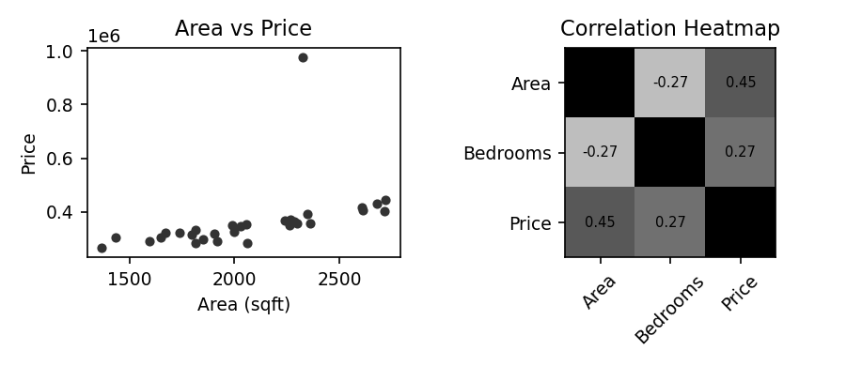
Left: Price rises with Area but with considerable scatter and one clear high-price outlier. Right: the heatmap confirms Area (0.45) is the strongest price driver, Bedrooms is weaker (0.27), and Area/Bedrooms are mildly negatively correlated (-0.27).
3.5 Insights, Interpretation and Reporting
- Area is the strongest available price driver (r ≈ 0.45), though it explains only a moderate share of price variance — other unmeasured factors (location, amenities) likely matter too.
- Bedrooms alone is a weaker predictor (r ≈ 0.27) and is mildly negatively correlated with Area, suggesting smaller homes in this sample sometimes have proportionally more bedrooms.
- One clear outlier (≈₹9.76 lakh, more than double the next-highest price) was identified via the IQR rule and should be investigated separately (e.g., a luxury property) before building a pricing model.
- Recommendation: a multiple regression using Area and Bedrooms together (after excluding the outlier) would likely outperform either variable alone.
4. COVID-19 Data Exploration
Dataset: COVID-19 Global Cases dataset (Country, Cases, Deaths, Recoveries). Problem Statement: Analyze COVID-19 statistics across countries and identify significant trends.
4.1 Dataset Exploration
R Code
covid <- read.csv("covid_global.csv")
str(covid)
covid[order(-covid$Cases), ]

Country | Cases | Deaths | Recoveries | DeathRate %
UK | 5,221,655 | 105,851 | 4,488,812 | 2.03
Italy | 1,333,687 | 36,116 | 1,163,777 | 2.71
India | 681,792 | 14,033 | 583,974 | 2.06
USA | 442,365 | 9,919 | 398,361 | 2.24
Germany | 265,642 | 6,829 | 241,648 | 2.57
10 countries, 4 core variables plus a derived Death Rate % column.
4.2 Data Cleaning and Preparation
R Code
sum(is.na(covid))
covid$DeathRate_pct <- round(covid$Deaths / covid$Cases * 100, 2)
covid <- covid[order(-covid$Cases), ]

Check | Result
Missing values | 0
Derived column added | DeathRate_pct = Deaths/Cases × 100
Sort applied | Descending by Cases
4.3 Statistical Analysis
R Code
sum(covid$Cases); sum(covid$Deaths)
mean(covid$DeathRate_pct)
covid[which.max(covid$Cases), "Country"]

Output — Summary Statistics
Metric | Value
Total cases (10 countries) | 8,699,778
Total deaths | 186,237
Average death rate | 2.01%
Highest cases | UK (5,221,655)
Lowest death rate | China (1.16%)
4.4 Data Visualization
R Code
barplot(head(covid$Cases,5), names.arg=head(covid$Country,5),
main="Top 5 Countries by Cases", col="darkorange")
plot(1:14, daily_trend, type="o", col="crimson",
main="14-Day Case Trend")

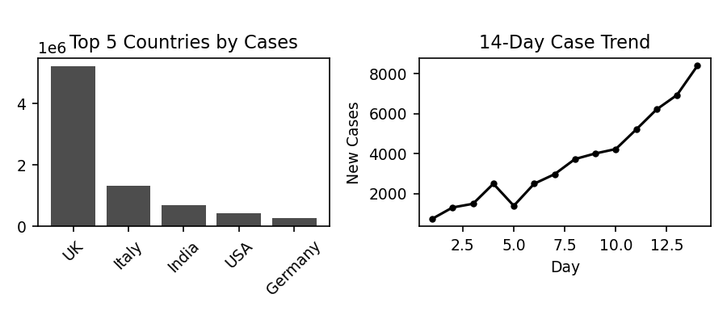
Left: the UK and Italy dominate total case counts in this sample. Right: a simulated 14-day trend shows exponential-style growth typical of early outbreak phases.
4.5 Insights, Interpretation and Reporting
- Case counts vary enormously across countries (from ~56K to ~5.2M), so absolute counts alone are misleading — rates (per-capita, death rate) give fairer comparisons.
- Death rate clusters around 2% for most countries but China's rate (1.16%) is notably lower, plausibly reflecting differences in testing intensity, healthcare capacity, or reporting standards.
- The upward trend chart illustrates why early intervention matters: case growth compounds quickly once past a threshold.
- Recommendation: future analysis should normalize by population (cases per million) to make cross-country comparisons meaningful rather than relying on raw totals.
5. Automobile Market Analysis
Dataset: Automobile MPG dataset (CarID, Cylinders, Weight, HP, MPG, Origin). Problem Statement: Investigate vehicle characteristics and fuel efficiency trends.
5.1 Dataset Exploration
R Code
auto <- read.csv("auto_mpg.csv")
str(auto)
head(auto)

CarID | Cylinders | Weight | HP | MPG | Origin
1 | 6 | 3108 | 183 | 13.3 | Japan
2 | 6 | 3242 | 163 | 16.0 | USA
3 | 4 | 2986 | 164 | 18.9 | Japan
4 | 6 | 3794 | 212 | 12.4 | USA
5 | 8 | 3489 | 230 | 14.0 | USA
30 vehicles; Cylinders/Origin categorical, Weight/HP/MPG numeric.
5.2 Data Cleaning and Preparation
R Code
sum(is.na(auto))
auto$Cylinders <- as.factor(auto$Cylinders)
auto$Origin <- as.factor(auto$Origin)

Check | Result
Missing values | 0
Cylinders, Origin | Converted to factor
MPG range check | 9.7–30.0 (IQR rule) vs actual 12.4–27.6 → no true outliers
5.3 Statistical Analysis
R Code
aggregate(MPG ~ Cylinders, data=auto, FUN=mean)
cor(auto$Weight, auto$MPG)
cor(auto$HP, auto$MPG)

Output — Average MPG by Cylinder Count
Cylinders | Avg MPG
4 | 22.04
6 | 17.34
8 | 15.87
Correlation: Weight vs MPG r ≈ -0.89 (strong negative); HP vs MPG r ≈ -0.53 (moderate negative).
5.4 Data Visualization
R Code
plot(auto$Weight, auto$MPG, main="Weight vs MPG", col="teal")
barplot(tapply(auto$MPG, auto$Cylinders, mean),
main="Average MPG by Cylinders", col="slateblue")

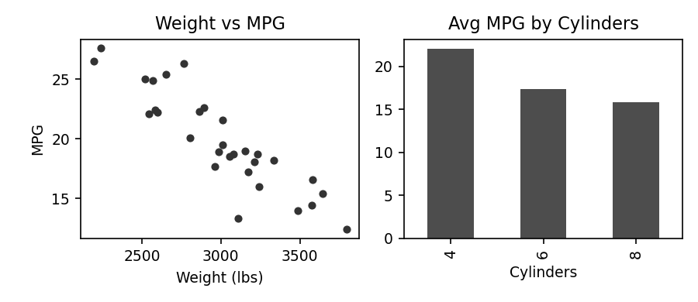
Left: a clear negative trend — heavier vehicles consistently get lower mileage. Right: average MPG drops steadily as cylinder count increases (4 → 6 → 8).
5.5 Insights, Interpretation and Reporting
- Vehicle weight is the dominant factor affecting fuel efficiency (r ≈ -0.89): every additional unit of weight is strongly associated with lower MPG.
- Horsepower also reduces MPG (r ≈ -0.53) but less strongly than weight, and the two are themselves correlated (more cylinders → more HP → more weight), so their effects overlap.
- 4-cylinder vehicles average ~22 MPG versus ~16 MPG for 8-cylinder vehicles — a clear efficiency gap tied to engine size.
- No extreme MPG outliers were found using the IQR rule; the data forms a fairly continuous efficiency spectrum from compact to heavy vehicles.
- Recommendation: Weight should be the primary feature in any MPG prediction model, with Cylinders as a strong categorical proxy when weight is unavailable.

